X400 Production Self-Test Software

Step 1, go online
The first time you run the printer, you'll need to retrieve the UUID before you can connect to it.
If the error message displays "serial," it means the printer can't recognize the motherboard and extruder. You'll need to enter the console interface and type a capital "W" to retrieve the UUID.
As shown below, once the two UUID lines appear, reconnect to the printer in the main interface. If you still can't retrieve the UUID, power cycle the printer and try again.
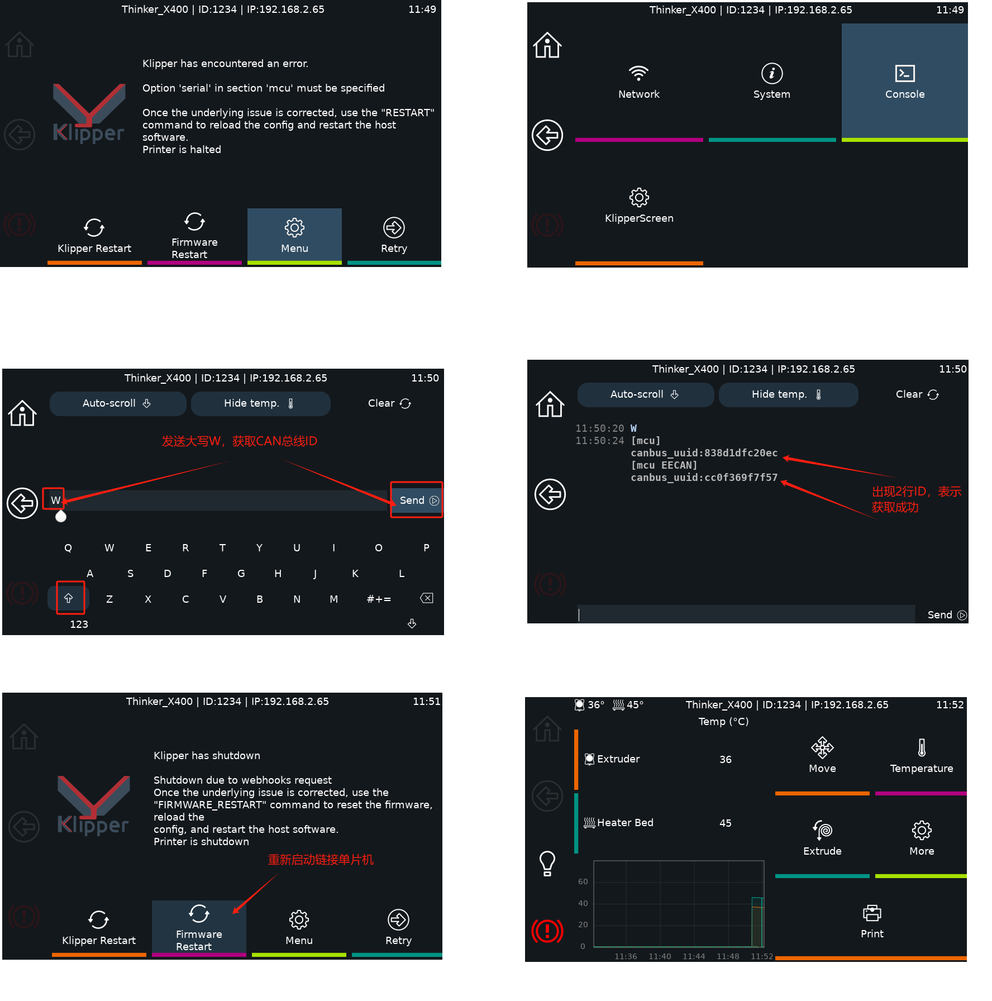

Step 2: Check Motor Direction
1. Ensure the extruder is centered in the printer to prevent collisions with the heated bed or the printer while the motor is running.
2. Perform the Motor Home All operation to check that the X, Y, and Z motors are running correctly.
3. If the motor is running in the wrong direction, immediately click the Stop button or disconnect the power cord. After correcting any hardware connection issues, click Restart Firmware to reconnect.

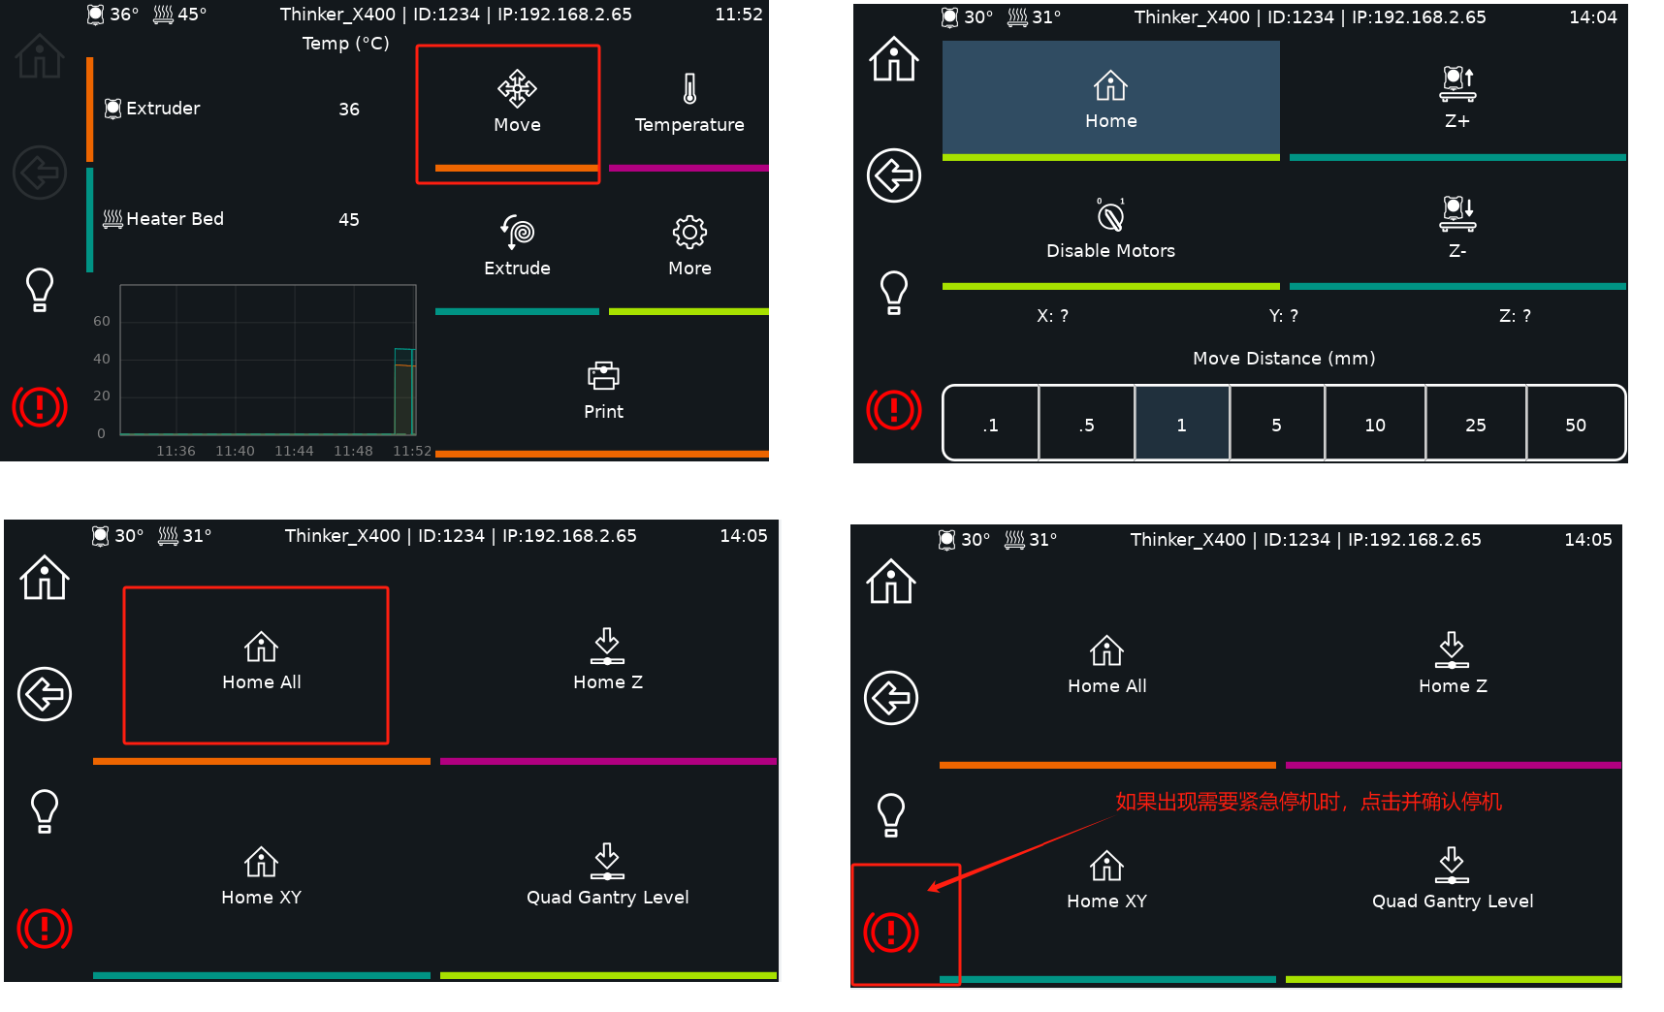

Step 3: Heating Check
1. Enter the temperature interface and preheat the PLA.
2. Check if the extruder and heated bed are heated. If not, check the hardware connections.

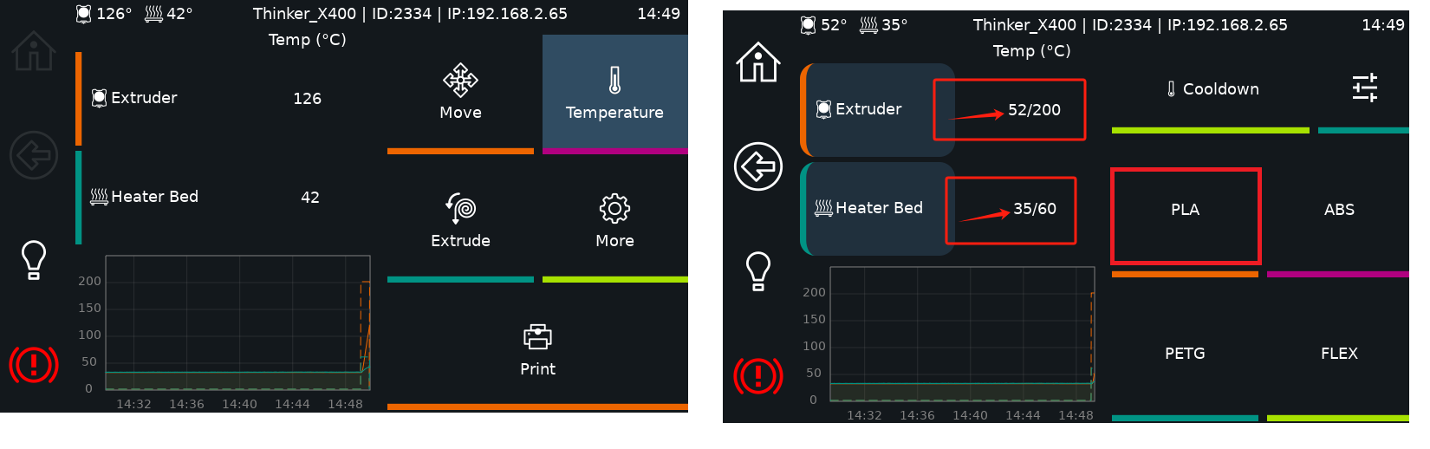

Step 4, automatic calibration

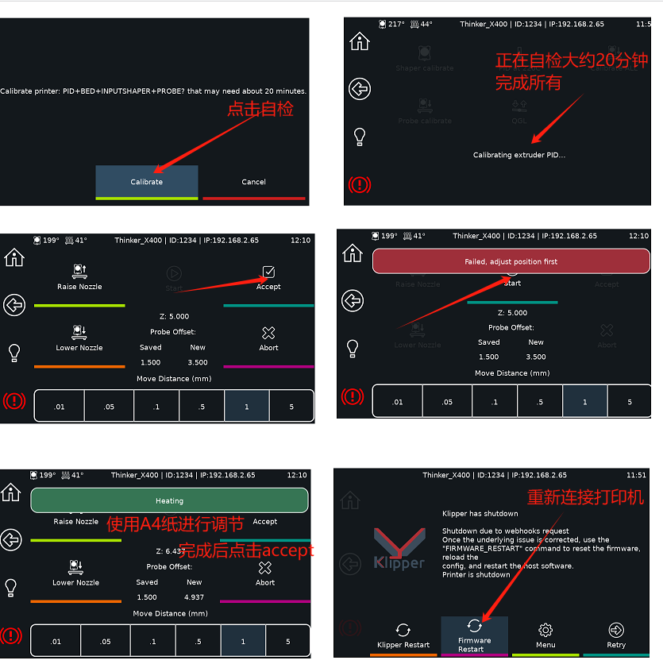

After calibrating and saving the parameters, do not turn off the power immediately, otherwise the data may not be saved. To properly shut down the system:
Shutdown steps: Settings ---> System ---> Shutdown console ----> Wait for the screen to go black ----> Physically turn off the power.

Step 5: Incoming/outgoing material inspection
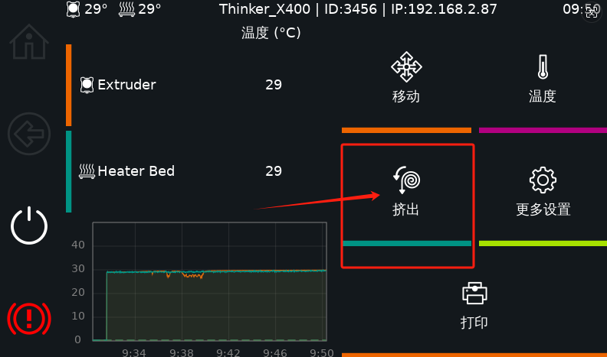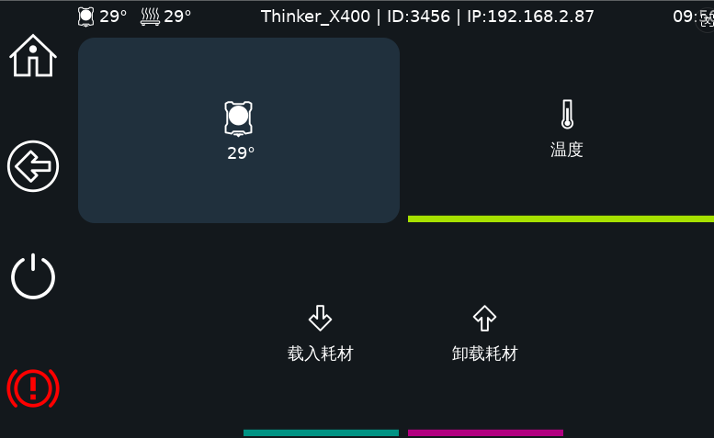

When feeding and discharging for the first time, you need to wait until the temperature reaches 230°C before the extruder motor will work.

Step 6 (Optional): Network Upgrade
Plugging in the network cable will automatically display the IP address. The network upgrade will then begin. The upgrade button will be stuck for a moment until the upgrade is successful. After the initial upgrade, you'll need to reinstall the device for the software to take effect.
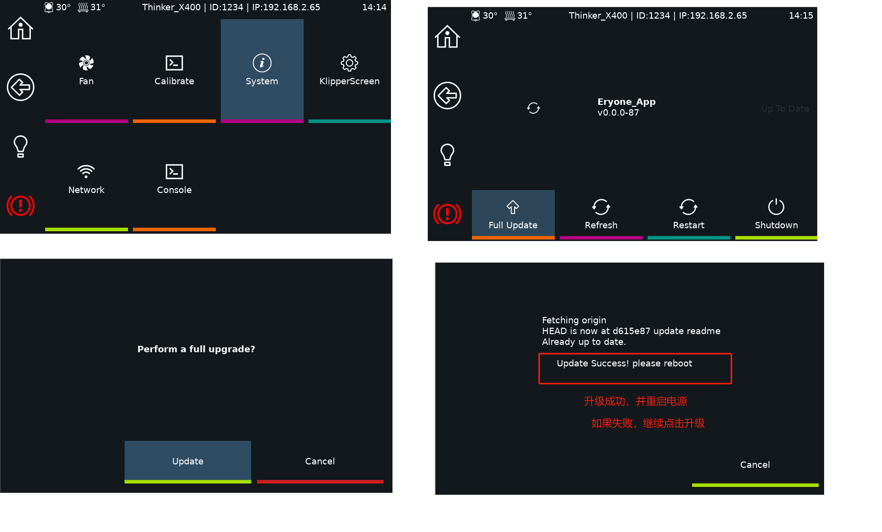

Step 7 (optional): Modify the device ID number
In the console interface, send a capital N followed by the ID number, Nxxxxx, for example, N3-2. After clicking send, the machine ID number will automatically update to 3-2
